Format Migration Tool Across Standard DB

- Contents…………………………………………………………………………………………………

2 .Introduction ……………………………………………………………………………………………..1
Vision
Scope
Definition, Acronyms, Abbreviations
Overview
Creating migration module
Xml configuration
Stored procedure migration module

- System Analysis ………………………………………………………………………………………10
Existing System
Limitations in Existing System
Proposed System
Problem Definition
Advantages over Existing System
Feasibility Study
Economic Feasibility
Operational Feasibility
Technical Feasibility

- Software Requirement Specification
Software Requirements
Hardware Requirements

4. System Design
Architecture Diagram
Maintenance
Functional Description
Functions

5. UML Diagrams ………………………………………………………………………………………
Activity Diagram …………………………………………………………………….
Class Diagram………………………………………………...................
Use-case Diagram ……………………………………………………………
Sequence Diagram ………………………………………………………..
Component Diagram ………………………………………………….
Deployment Diagram ………………………………………………..

6. Coding & Implementation
Technologies Used…………………………………………………………………………….
Java Technology……………………………………………………………

7. Code Snippets

8. Snapshots
9. Testing
Methodologies
Test Cases

10. Scope for Future Enhancements
11. Project Summary
12. User Manual / Technical Help Desk
13. Bibliography
Abstract
Format Migration Tool is a tool and Java API to migrate data from different sources (XML, DBF, CSV and JDBC) to another (DBF, CSV, JDBC, TXT). Configuration is specified by an XML file defining source, target and Schema transformations of the data.

Format Migration is a generic database migration tool. It can be connected to any Database that has a JDBC type 4 driver and generates data definition language script, insert statements, data files and related files to migrate the source database to any destination database. Currently it supports Oracle, MS SQL Server, MySQL and PostgreSql as destination, as well as source databases.

Data migration is the process of transferring data between storage types, formats, or computer systems. Data migration is usually performed programmatically to achieve an automated migration, freeing up human resources from tedious tasks. It is required when organizations or individuals change computer systems or upgrade to new systems, or when systems merge (such as when the organizations that use them undergo a merger/takeover).

To achieve an effective data migration procedure, data on the old system is mapped to the new system providing a design for data extraction and data loading. The design relates old data formats to the new system's formats and requirements. Programmatic data migration may involve many phases but it minimally includes data extraction where data is read from the old system and data loading where data is written to the new system.

Introduction
Vision
The vision of the project is to help the migration and transfer of database schemas and data across leading databases such as Oracle, IBM DB2, MS-SQL Server, Sybase, SAP DB, MySQL, PostgreSQL and MS Access.

Scope
The scope of the Format Migration Tool across Standard Database Formats is as follows:

The system scope includes the Supports migration/transfer of schema and data across Oracle, IBM DB2, SQL Server, Sybase, MySQL MaxDB, MySQL, PostgreSQL and MS Access databases.

- Migration of data from Excel and CSV (Comma Separated Value) files into databases.
- Migrates tables, indexes, constraints along with data.
- Supports basic features for Schema and Data transformation during migration
- Supports migrating stored procedures, functions, triggers, if the source and target RDBMS are the same. Following migration combinations are supported currently: SQL Server to SQL Server, Oracle to Oracle, DB2 to DB2 and Sybase to Sybase.
- Criteria based data migration (data subsetting) is supported when migrating from Oracle, SQL Server, MySQL, PostgreSQL and Sybase ASE to any database. User can set the filter criteria for a table(s) based on which, only the rows matching the criteria (subset) will be migrated. If a criterion is set for a table, then its dependant tables will also be migrated based on its relationship.

Definition, Acronyms, Abbreviations
RDBMS – Relational Database Management System
JDBC – Java Database Connectivity
Database - Database is a structured collection of records or Data.
XML – eXtensible Markup Language
DBF – Dbase File
CSV – Comma Separated Value
JDBC – Java Database Connectivity
TXT – Text File Format
RDBMS – Relational Database Management System

Overview
The project Entitled Format Migration Tool Across Standard Database Formats is mainly aimed at designing a tool to handle for migrating one database from a sources of data (RDBMS, CSV, XML and so on) to another changing database's schema if necessary.

A database management system (DBMS) is a computer program (or more typically, a suite of them) designed to manage a database, a large set of structured data, and run operations on the data requested by numerous users. Typical examples of DBMS use include accounting, human resources and customer support systems.

Originally found only in large companies with the computer hardware needed to support large data sets, DBMSs have more recently emerged as a fairly standard part of any company back office.

Creating migration module: This module is mainly developed for initial recognition of migration values and operationalising
CSV File Format - Comma Separated Values
The comma-separated values (or CSV; also known as a comma-separated list or comma-separated variables) file format is a file type that stores tabular data. The format dates back to the early days of business computing. For this reason, CSV files are common on all computer platforms.

CSV is one implementation of a delimited text file, which uses a comma to separate values (where many implementations of CSV import/export tools allow an alternate separator to be used; as is shown in the MS Access screen shot, below). However CSV differs from other delimiter separated file formats in using a " (double quote) character around fields that contain reserved characters (such as commas or newlines). Most other delimiter formats either use an escape character such as a backslash, or have no support for reserved characters.

In computer science terms, this type of format is called a "flat file" because only one table can be stored in a CSV file. Most systems use a series of tables to store their information, which must be "flattened" into a single table, often with information repeated over several rows, to create a delimited text file.

While no formal specification for CSV exists, RFC 4180 describes a common format and establishes "text/csv" as the MIME type registered with the IANA. Another relevant specification is provided by Fielded Text which also covers the CSV format.

Many informal documents exist that describe the CSV format. How To: The Comma Separated Value (CSV) File Format provides an overview of the CSV format in the most widely used applications and explains how it can best be used and supported.

The basic rules are as follows:
CSV is a delimited data format that has fields/columns separated by the comma character and records/rows separated by newlines. Fields that contain a special character (comma, newline, or double quote), must be enclosed in double quotes. However, if a line contains a single entry which is the empty string, it may be enclosed in double quotes. If a field's value contains a double quote character it is escaped by placing another double quote character next to it. The CSV file format does not require a specific character encoding, byte order, or line terminator format.
- Each record is one line terminated by a line feed (ASCII/LF=0x0A) or a carriage return and line feed pair (ASCII/CRLF=0x0D 0x0A), however, line-breaks can be embedded.
- Fields are separated by commas.

System Analysis

Existing System
The existing system consists of the collecting the data from the specified database and migrate (convert) that specified data into the required database format.

Limitations in Existing System
- The existing system doesn’t support all database formats.
- It is platform dependent.
- Doesn’t support CSV file format.

Proposed System
The proposed system consists of a tool and Java API to migrate data from different sources (XML, DBF, CSV, JDBC) to another (DBF, CSV, JDBC, TXT). Configured by an XML file defining source, target and schemas + transformations of the data.

Problem Definition
To connect any Database that has a JDBC type 4 driver and generates data definition language script, insert statements, data files and related files to migrate the source database to any destination database.

Advantages over Existing System
- Minimize expensive downtime by keeping applications available during migration
- Reduce risk by leveraging Sun’s experience, proven methodologies, and best practices
- Get vendor-independent recommendations for flexibility and choice so user can create a migration solution based on unique requirements
- Receive industry veteran storage and data management expertise to investigate, justify, design, plan, and implement a data migration solution
Feasibility Study
Economic Feasibility
Economic feasibility attempts 2 weigh the costs of developing and implementing a new system, against the benefits that would accrue from having the new system in place. This feasibility study gives the top management the economic justification for the new system.

A simple economic analysis which gives the actual comparison of costs and benefits are much more meaningful in this case. In addition, this proves to be a useful point of reference to compare actual costs as the project progresses. There could be various types of intangible benefits on account of automation. These could include increased customer satisfaction, improvement in product quality better decision making timeliness of information, expediting activities, improved accuracy of operations, better documentation and record keeping, faster retrieval of information, better employee morale.

Operational Feasibility
Proposed project is beneficial only if it can be turned into information systems that will meet the organizations operating requirements. Simply stated, this test of feasibility asks if the system will work when it is developed and installed. Are there major barriers to Implementation? Here are questions that will help test the operational feasibility of a project:

Is there sufficient support for the project from management from users? If the current system is well liked and used to the extent that persons will not be able to see reasons for change, there may be resistance.

Are the current business methods acceptable to the user? If they are not, Users may welcome a change that will bring about a more operational and useful systems.
Have the user been involved in the planning and development of the project?

Early involvement reduces the chances of resistance to the system and in general and increases the likelihood of successful project.

Since the proposed system was to help reduce the hardships encountered. In the existing manual system, the new system was considered to be operational feasible.

Technical Feasibility
Evaluating the technical feasibility is the trickiest part of a feasibility study. This is because, .at this point in time, not too many detailed design of the system, making it difficult to access issues like performance, costs on (on account of the kind of technology to be deployed) etc. A number of issues have to be considered while doing a technical analysis.

Understand the different technologies involved in the proposed system before commencing the project we have to be very clear about what are the technologies that are to be required for the development of the new system. Find out whether the organization currently possesses the required technologies. Is the required technology available with the organization?

Software Requirement Specification

Software Requirements
Operating System : Windows XP/2003 or Linux/Solaris
Programming Language : Java
Data Structures : Java Collections API
Graphical User Interface : Java Swing
Networking Programming : Java Socket API
IDE/Workbench : Eclipse with MyEclipse Plug-in

Hardware Requirements
Processor : Pentium IV
Hard Disk : 40GB
RAM : 256MB

System Design

Architecture Diagram

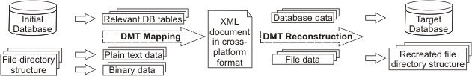

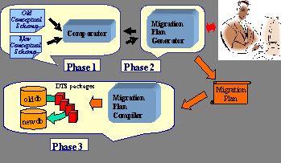
Maintenance
Functional Description
This project consists of the following modules:
Database Migration is a generic database migration tool. It can be connected to any Database that has a JDBC type 4 driver and generates data definition language script, insert statements, data files and related files to migrate the source database to any destination database. Currently it supports Oracle, MS SQL Server, MySQL and PostgreSql as destination, as well as source databases.

To achieve an effective data migration procedure, data on the old system is mapped to the new system providing a design for data extraction and data loading. The design relates old data formats to the new system's formats and requirements. Programmatic data migration may involve many phases but it minimally includes data extraction where data is read from the old system and data loading where data is written to the new system.

After loading into the new system, results are subjected to data verification to determine that data was accurately translated, is complete, and supports processes in the new system. During verification, there may be a need for a parallel run of both systems to identify areas of disparity and forestall erroneous data loss.

Automated and manual data cleansing is commonly performed in migration to improve data quality, eliminate redundant or obsolete information, and match the requirements of the new system.
Data migration phases (design, extraction, cleansing, load, verification) for applications of moderate to high complexity are commonly repeated several times before the new system is activated.

DBMT uses SQLJEP for manipulating and filtering source tables. SQLJEP supports almost all Oracle's and Maxdb's SQL functions. DBMT with SQLJEP can be used as simple query engine for manipulating with CSV and DBF or other data files.

A complete Data Migration Tool that helps the migration and transfer of database schemas and data across leading databases such as Oracle, IBM DB2, MS-SQL Server, Sybase, SAP DB, MySQL, PostgreSQL and MS Access. It offers an open, user-friendly, and extensible migration process ensuring reliability and data integrity.

Functions

The Database Migration Tool is a GUI-based, Java application for exchanging files and/or relational database data between different platforms by
• mapping the content into a transfer-safe, plain text format included in an XML document as well as
• reconstruction of the migrated data from the XML document through converting it back to its primary format, thereby preserving the original file hierarchy.

UML Diagrams
The unified modeling language allows the software engineer to express an analysis model using the modeling notation that is governed by a set of syntactic semantic and pragmatic rules.

A UML system is represented using five different views that describe the system from distinctly different perspective. Each view is defined by a set of diagram, which is as follows.
  - User Model View
    - This view represents the system from the users perspective.
    - The analysis representation describes a usage scenario from the end-users perspective.

  - Structural model view
    - In this model the data and functionality are arrived from inside the system.
    - This model view models the static structures.

- Behavioral Model View
It represents the dynamic of behavioral as parts of the system, depicting the interactions of collection between various structural elements described in the user model and structural model view.

- Implementation Model View
In this the structural and behavioral as parts of the system are represented as they are to be built.

- Environmental Model View
In this the structural and behavioral aspects of the environment in which the system is to be implemented are represented.

UML is specifically constructed through two different domains they are:
- UML Analysis modeling, this focuses on the user model and structural model views of the system.
- UML design modeling, which focuses on the behavioral modeling, implementation modeling and environmental model views.

Use case Diagrams represent the functionality of the system from a user’s point of view. Use cases are used during requirements elicitation and analysis to represent the functionality of the system. Use cases focus on the behavior of the system from external point of view.

Actors are external entities that interact with the system. Examples of actors include users like administrator, bank customer …etc., or another system like central database.

Activity Diagram
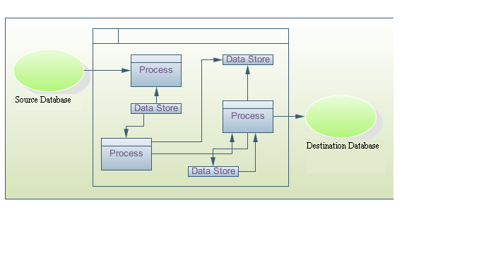
Class Diagram
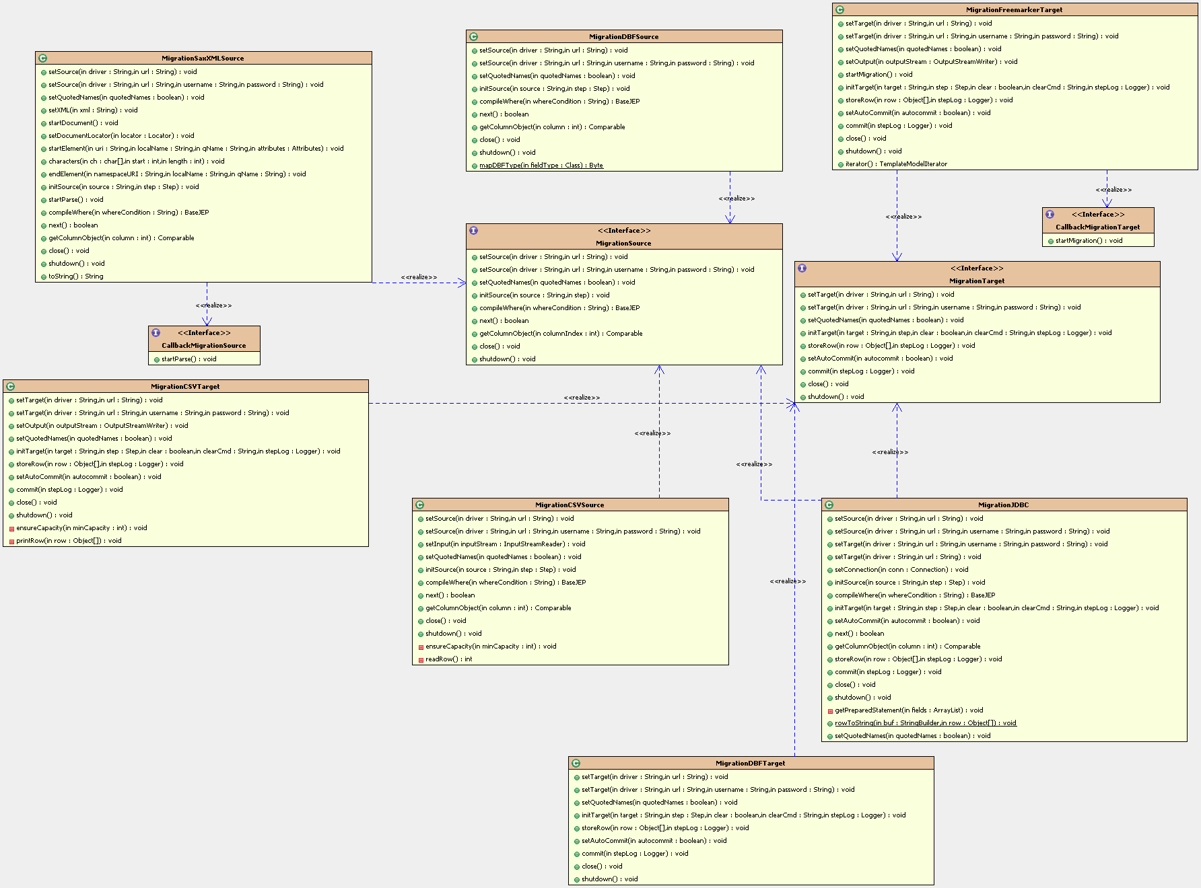
Use-case Diagram
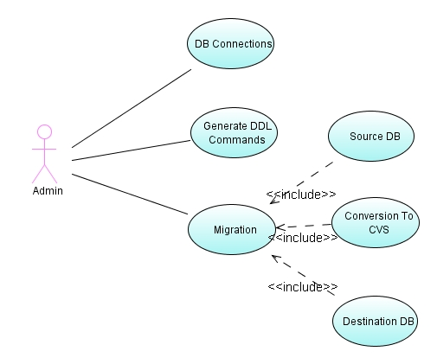
Sequence Diagram

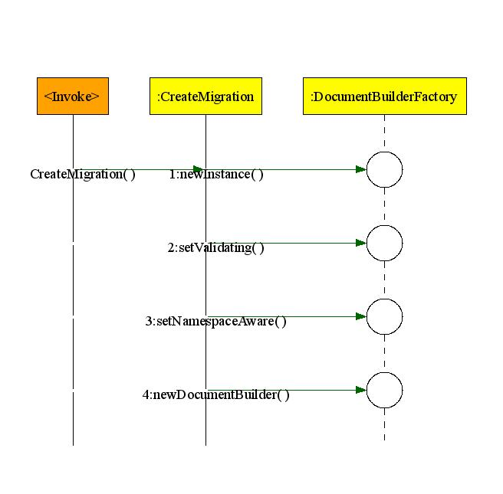
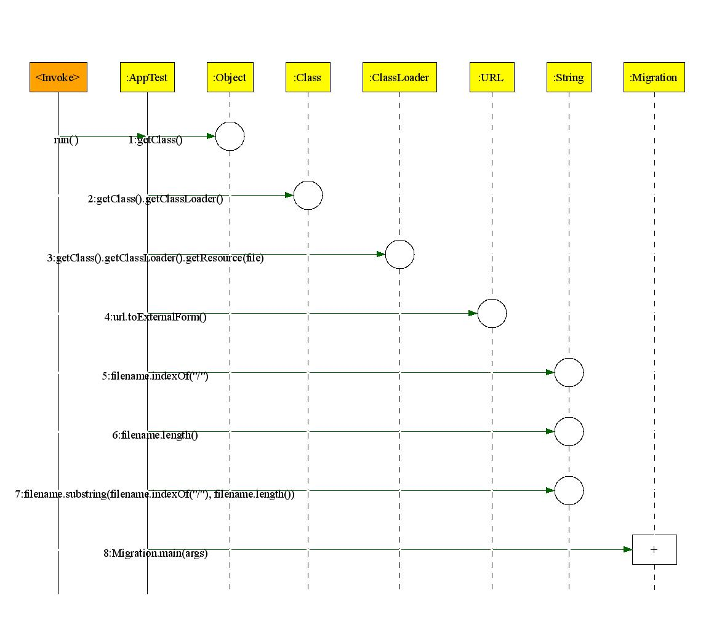
Component Diagram

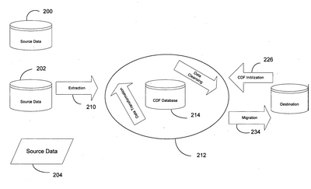
Deployment Diagram

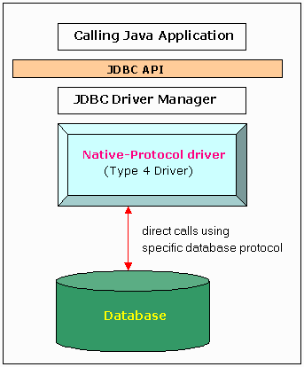

Coding
&
Implementation

Technologies Used

Java Technology
Initially the language was called as “oak” but it was renamed as “Java” in 1995. The primary motivation of this language was the need for a platform-independent (i.e., architecture neutral) language that could be used to create software to be embedded in various consumer electronic devices.
- Java is a programmer’s language.
- Java is cohesive and consistent.
- Except for those constraints imposed by the Internet environment, Java gives the programmer, full control.
- Finally, Java is to Internet programming where C was to system programming.

Importance of Java to the Internet
Java has had a profound effect on the Internet. This is because; Java expands the Universe of objects that can move about freely in Cyberspace. In a network, two categories of objects are transmitted between the Server and the Personal computer. They are: Passive information and Dynamic active programs. The Dynamic, Self-executing programs cause serious problems in the areas of Security and probability. But, Java addresses those concerns and by doing so, has opened the door to an exciting new form of program called the Applet.

Java can be used to create two types of programs
Applications and Applets: An application is a program that runs on our Computer under the operating system of that computer. It is more or less like one creating using C or C++. Java’s ability to create Applets makes it important. An Applet is an application designed to be transmitted over the Internet and executed by a Java –compatible web browser. An applet is actually a tiny Java program, dynamically downloaded across the network, just like an image. But the difference is, it is an intelligent program, not just a media file. It can react to the user input and dynamically change.

Features of Java Security
Every time you that you download a “normal” program, you are risking a viral infection. Prior to Java, most users did not download executable programs frequently, and those who did scan them for viruses prior to execution. Most users still worried about the possibility of infecting their systems with a virus. In addition, another type of malicious program exists that must be guarded against. This type of program can gather private information, such as credit card numbers, bank account balances, and passwords. Java answers both these concerns by providing a “firewall” between a network application and your computer.
When you use a Java-compatible Web browser, you can safely download Java applets without fear of virus infection or malicious intent.

Portability
For programs to be dynamically downloaded to all the various types of platforms connected to the Internet, some means of generating portable executable code is needed .As you will see, the same mechanism that helps ensure security also helps create portability. Indeed, Java’s solution to these two problems is both elegant and efficient.

The Byte code
The key that allows the Java to solve the security and portability problems is that the output of Java compiler is Byte code. Byte code is a highly optimized set of instructions designed to be executed by the Java run-time system, which is called the Java Virtual Machine (JVM). That is, in its standard form, the JVM is an interpreter for byte code.
Translating a Java program into byte code helps makes it much easier to run a program in a wide variety of environments. The reason is, once the run-time package exists for a given system, any Java program can run on it.
Although Java was designed for interpretation, there is technically nothing about Java that prevents on-the-fly compilation of byte code into native code. Sun has just completed its Just In Time (JIT) compiler for byte code. When the JIT compiler is a part of JVM, it compiles byte code into executable code in real time, on a piece-by-piece, demand basis. It is not possible to compile an entire Java program into executable code all at once, because Java performs various run-time checks that can be done only at run time. The JIT compiles code, as it is needed, during execution.

Java Virtual Machine (JVM)
Beyond the language, there is the Java virtual machine. The Java virtual machine is an important element of the Java technology. The virtual machine can be embedded within a web browser or an operating system. Once a piece of Java code is loaded onto a machine, it is verified. As part of the loading process, a class loader is invoked and does byte code verification makes sure that the code that’s has been generated by the compiler will not corrupt the machine that it’s loaded on. Byte code verification takes place at the end of the compilation process to make sure that is all accurate and correct. So byte code verification is integral to the compiling and executing of Java code.

Overall Description
Java Source
Java byte code
JavaVM
Java
.Class

Picture showing the development process of JAVA Program
Java programming uses to produce byte codes and executes them. The first box indicates that the Java source code is located in a. Java file that is processed with a Java compiler called javac. The Java compiler produces a file called a. class file, which contains the byte code. The .Class file is then loaded across the network or loaded locally on your machine into the execution environment is the Java virtual machine, which interprets and executes the byte code.

Java Architecture
Java architecture provides a portable, robust, high performing environment for development. Java provides portability by compiling the byte codes for the Java Virtual Machine, which is then interpreted on each platform by the run-time environment. Java is a dynamic system, able to load code when needed from a machine in the same room or across the planet.

Compilation of code
When you compile the code, the Java compiler creates machine code (called byte code) for a hypothetical machine called Java Virtual Machine (JVM). The JVM is supposed to execute the byte code. The JVM is created for overcoming the issue of portability. The code is written and compiled for one machine and interpreted on all machines. This machine is called Java Virtual Machine.

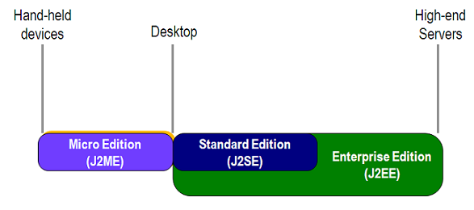

Compiling and interpreting Java Source Code
During run-time the Java interpreter tricks the byte code file into thinking that it is running on a Java Virtual Machine. In reality this could be a Intel Pentium Windows 95 or SunSARC station running Solaris or Apple Macintosh running system and all could receive code from any computer through Internet and run the Applets.

Simple
Java was designed to be easy for the Professional programmer to learn and to use effectively. If you are an experienced C++ programmer, learning Java will be even easier. Because Java inherits the C/C++ syntax and many of the objects oriented features of C++. Most of the confusing concepts from C++ are either left out of Java or implemented in a cleaner, more approachable manner. In Java there are a small number of clearly defined ways to accomplish a given task.

Object-Oriented
Java was not designed to be source-code compatible with any other language. This allowed the Java team the freedom to design with a blank slate. One outcome of this was a clean usable, pragmatic approach to objects. The object model in Java is simple and easy to extend, while simple types, such as integers, are kept as high-performance non-objects.

Robust
The multi-platform environment of the Web places extraordinary demands on a program, because the program must execute reliably in a variety of systems. The ability to create robust programs was given a high priority in the design of Java. Java is strictly typed language; it checks your code at compile time and run time.
Java virtually eliminates the problems of memory management and de-allocation, which is completely automatic. In a well-written Java program, all run time errors can –and should –be managed by your program.

Java Collections
A collection — sometimes called a container — is simply an object that groups multiple elements into a single unit. Collections are used to store, retrieve, manipulate, and communicate aggregate data. Typically, they represent data items that form a natural group, such as a poker hand (a collection of cards), a mail folder (a collection of letters), or a telephone directory (a mapping of names to phone numbers).
If you've used the Java programming language — or just about any other programming language — you're already familiar with collections. Collection implementations in earlier (pre-1.2) versions of the Java platform included Vector, Hashtable, and array. However, those earlier versions did not contain a collections framework.
A collections framework is a unified architecture for representing and manipulating collections. All collections frameworks contain the following:
Interfaces: These are abstract data types that represent collections. Interfaces allow collections to be manipulated independently of the details of their representation. In object-oriented languages, interfaces generally form a hierarchy.
Implementations: These are the concrete implementations of the collection interfaces. In essence, they are reusable data structures.
Algorithms: These are the methods that perform useful computations, such as searching and sorting, on objects that implement collection interfaces. The algorithms are said to be polymorphic: that is, the same method can be used on many different implementations of the appropriate collection interface. In essence, algorithms are reusable functionality.
Benefits of the Java Collections Framework
The Java Collections Framework provides the following benefits:
Reduces programming effort: By providing useful data structures and algorithms, the Collections Framework frees you to concentrate on the important parts of your program rather than on the low-level "plumbing" required to make it work. By facilitating interoperability among unrelated APIs, the Java Collections Framework frees you from writing adapter objects or conversion code to connect APIs.
Increases program speed and quality: This Collections Framework provides high performance, high-quality implementations of useful data structures and algorithms. The various implementations of each interface are interchangeable, so programs can be easily tuned by switching collection implementations. Because you're freed from the drudgery of writing your own data structures, you'll have more time to devote to improving programs' quality and performance.
Allows interoperability among unrelated APIs: The collection interfaces are the vernacular by which APIs pass collections back and forth. If my network administration API furnishes a collection of node names and if your GUI toolkit expects a collection of column headings, our APIs will interoperate seamlessly, even though they were written independently.
Reduces effort to learn and to use new APIs: Many APIs naturally take collections on input and furnish them as output. In the past, each such API had a small sub-API devoted to manipulating its collections. There was little consistency among these ad hoc collections sub-APIs, so you had to learn each one from scratch, and it was easy to make mistakes when using them. With the advent of standard collection interfaces, the problem went away.
Reduces effort to design new APIs: This is the flip side of the previous advantage. Designers and implementers don't have to reinvent the wheel each time they create an API that relies on collections; instead, they can use standard collection interfaces.
Fosters software reuse: New data structures that conform to the standard collection interfaces are by nature reusable. The same goes for new algorithms that operate on objects that implement these interfaces.
The core collection interfaces:
A Set is a special kind of Collection, a SortedSet is a special kind of Set, and so forth. Note also that the hierarchy consists of two distinct trees — a Map is not a true Collection.
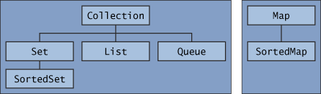
Note that all the core collection interfaces are generic. For example, this is the declaration of the Collection interface.
public interface Collection<E>...
The following list describes the core collection interfaces:
Collection — the root of the collection hierarchy. A collection represents a group of objects known as its elements. The Collection interface is the least common denominator that all collections implement and is used to pass collections around and to manipulate them when maximum generality is desired. Some types of collections allow duplicate elements, and others do not. Some are ordered and others are unordered. The Java platform doesn't provide any direct implementations of this interface but provides implementations of more specific sub interfaces, such as Set and List. Also see The Collection Interface section.
Set — a collection that cannot contain duplicate elements. This interface models the mathematical set abstraction and is used to represent sets, such as the cards comprising a poker hand, the courses making up a student's schedule, or the processes running on a machine. See also The Set Interface section.
List — an ordered collection (sometimes called a sequence). Lists can contain duplicate elements. The user of a List generally has precise control over where in the list each element is inserted and can access elements by their integer index (position). If you've used Vector, you're familiar with the general flavor of List. Also see The List Interface section.
Queue — a collection used to hold multiple elements prior to processing. Besides basic Collection operations, a Queue provides additional insertion, extraction, and inspection operations. Queues typically, but do not necessarily, order elements in a FIFO (first-in, first-out) manner. Among the exceptions are priority queues, which order elements according to a supplied comparator or the elements' natural, ordering? Whatever the ordering used, the head of the queue is the element that would be removed by a call to remove or poll. In a FIFO queue, all new elements are inserted at the tail of the queue. Other kinds of queues may use different placement rules. Every Queue implementation must specify its ordering properties. Also see The Queue Interface section.
A Queue is a collection for holding elements prior to processing. Besides basic Collection operations, queues provide additional insertion, removal, and inspection operations.

Each Queue method exists in two forms: (1) one throws an exception if the operation fails, and (2) the other returns a special value if the operation fails (either null or false, depending on the operation). The regular structure of the interface is illustrated in the following table.
Map — an object that maps keys to values. A Map cannot contain duplicate keys; each key can map to at most one value. If you've used Hashtable, you're already familiar with the basics of Map. Also see The Map Interface section. The last two core collection interfaces are merely sorted versions of Set and
Map:
SortedSet — a Set that maintains its elements in ascending order. Several additional operations are provided to take advantage of the ordering. Sorted sets are used for naturally ordered sets, such as word lists and membership rolls. Also see The SortedSet Interface section.
SortedMap — a Map that maintains its mappings in ascending key order. This is the Map analog of SortedSet. Sorted maps are used for naturally ordered collections of key/value pairs, such as dictionaries and telephone directories. Also see The SortedMap Interface section.
Iterators: An Iterator is an object that enables you to traverse through a collection and to remove elements from the collection selectively, if desired. You get an Iterator for a collection by calling its iterator method. The following is the Iterator interface.
public interface Iterator<E> {
boolean hasNext();
E next();
void remove(); //optional
}

The hasNext method returns true if the iteration has more elements, and the next method returns the next element in the iteration. The remove method removes the last element that was returned by next from the underlying Collection. The remove method may be called only once per call to next and throws an exception if this rule is violated.
Bulk operations perform an operation on an entire Collection. You could implement these shorthand operations using the basic operations, though in most cases such implementations would be less efficient. The following are the bulk operations:
containsAll — returns true if the target Collection contains all of the elements in the specified Collection.
addAll — adds all of the elements in the specified Collection to the target Collection.
removeAll — removes from the target Collection all of its elements that are also contained in the specified Collection.
retainAll — removes from the target Collection all its elements that are not also contained in the specified Collection. That is, it retains only those elements in the target Collection that are also contained in the specified Collection.
clear — removes all elements from the Collection.
The addAll, removeAll, and retainAll methods all return true if the target Collection was modified in the process of executing the operation.
Java Swing
Swing Components enable the user to build functionally rich user interfaces. The Swing graphical user interface components were introduced with the Java Foundation Classes (JFC) as a downloadable extension to the Java 1.1 Platform then became a standard extension in the Java 2 Platform. Swing provides a more complete set of GUI components than the Abstract Windowing Toolkit (AWT), including advanced features such as a pluggable look and feel, lightweight component rendering and drag-and-drop capabilities.

Swing Text Components and HTML Rendering
Many applications present text to the user for viewing and editing. This text may consist of plain, unformatted characters, or it may consist of richly styled characters that use multiple fonts and extensive formatting. Swing provides three basic types of text components for presenting and editing text. Class JTextComponent is the base class for all Swing text components, including JTextField, JTextArea and JEditorPane. JTextField is a single-line text component suitable for obtaining simple user input or displaying information such as form field values, calculation results and so on. JpasswordField is a subclass of JTextField suitable for obtaining user passwords. These components do not perform any special text styling. Rather, they present all text in a single font and color. JTextArea, like JTextField and JPasswordField, also does not style its text. However, JTextArea does provide a larger visible area and supports larger plain-text documents.

JEditorPane provides enhanced text-rendering capabilities. JEditorPane supports styled documents that include formatting, font and color information. JEditor- Pane is capable of rendering HTML documents as well as Rich Text Format (RTF) documents. We use class JEditorPane to render HTML pages for a simple Web browser application. JTextPane is a JEditorPane subclass that renders only styled documents, and not plain text. JTextPane provides developers with fine-grained control over the style of each character and paragraph in the rendered document.

Swing Toolbars
Toolbars are GUI containers typically located below an application’s menus. Toolbars contain buttons and other GUI components for commonly used features, such as cut, copy and paste, or navigation buttons for a Web browser. Figure 2.2 shows toolbars in Internet Explorer and Mozilla. Class javax.swing.JToolBar enables developers to add toolbars to Swing user interfaces. JToolBar also enables users to modify the appearance of the JToolBar in a running application. For example, the user can drag the JToolBar from the top of a window and "dock" the JToolBar on the side or bottom of the window.

JSplitPane and JTabbedPane
JSplitPane and JTabbedPane are container components that enable developers to present large amounts of information in a small screen area. JSplitPane accomplishes this by dividing two components with a divider users can reposition to expand and contract the visible areas of the JSplitPane’s child components (Fig. 2.7). JTabbedPane uses a filefolder- style tab interface to arrange many components through which the user can browse.

Java Swing provides classes JDesktopPane and JInternalFrame for building multiple-document interfaces. These class names reinforce the idea that each document is a separate window (JInternalFrame) inside the application’s desktop (JDesktop-Pane), just as other applications are separate windows (e.g., JFrames) on the operating system’s desktop. JInternalFrames behave much like JFrames. Users can maximize, iconify, resize, open and close JInternalFrames. JInternalFrames have title bars with buttons for iconifying, maximizing and closing. Users also can move JInternal-Frames within the JDesktopPane.

Drag and drop is a common way to manipulate data in a GUI. Most GUIs emulate real world desktops, with icons that represent the objects on a virtual desk. Drag and drop enables users to move items around the desktop and to move and copy data among applications using mouse gestures. A gesture is a mouse movement that corresponds to a drag and-drop operation, such as dragging a file from one folder and dropping the file into another folder. Two Java APIs enable drag-and-drop data transfer between applications. The data transfer API—package java.awt.datatransfer—enables copying and moving data within a single application or among multiple applications. The drag-and-drop API enables Java applications to recognize drag-and-drop gestures and to respond to drag-and drop operations. A drag-and-drop operation uses the data transfer API to transfer data from the drag source to the drop target. For example, a user could begin a drag gesture in a filemanager application (the drag source) to drag a file from a folder and drop the file on a Java application (the drop target). The Java application would use the drag-and-drop API to recognize that a drag-and-drop operation occurred and would use the data transfer API to retrieve the data transferred through the drag-and-drop operation.

Java Networking
Computers running on the Internet communicate to each other using either the Transmission Control Protocol (TCP) or the User Datagram Protocol (UDP), When you write Java programs that communicate over the network, you are programming at the application layer. Typically, you don't need to concern yourself with the TCP and UDP layers. Instead, you can use the classes in the java.net package. These classes provide system-independent network communication. However, to decide which Java classes your programs should use, you do need to understand how TCP and UDP differ.
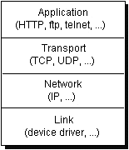
TCP -Transmission Control Protocol is a connection-based protocol that provides a reliable flow of data between two computers. TCP provides a point-to-point channel for applications that require reliable communications. The Hypertext Transfer Protocol (HTTP), File Transfer Protocol (FTP), and Telnet are all examples of applications that require a reliable communication channel. The order in which the data is sent and received over the network is critical to the success of these applications. When HTTP is used to read from a URL, the data must be received in the order in which it was sent. Otherwise, you end up with a jumbled HTML file, a corrupt zip file, or some other invalid information.

UDP (User Datagram Protocol) is a protocol that sends independent packets of data, called datagrams, from one computer to another with no guarantees about arrival. UDP is not connection-based like TCP. The UDP protocol provides for communication that is not guaranteed between two applications on the network. UDP is not connection-based like TCP. Rather, it sends independent packets of data, called datagrams, from one application to another. Sending datagrams is much like sending a letter through the postal service: The order of delivery is not important and is not guaranteed, and each message is independent of any other.

Understanding Ports:
Data transmitted over the Internet is accompanied by addressing information that identifies the computer and the port for which it is destined. The computer is identified by its 32-bit IP address, which IP uses to deliver data to the right computer on the network. Ports are identified by a 16-bit number, which TCP and UDP use to deliver the data to the right application.

In connection-based communication such as TCP, a server application binds a socket to a specific port number. This has the effect of registering the server with the system to receive all data destined for that port. A client can then rendezvous with the server at the server's port, as illustrated here:

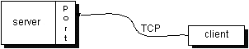

In datagram-based communication such as UDP, the datagram packet contains the port number of its destination and UDP routes the packet to the appropriate application, as illustrated in this figure:

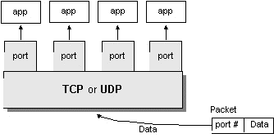

URL is the acronym for Uniform Resource Locator. It is a reference (an address) to a resource on the Internet. You provide URLs to your favorite Web browser so that it can locate files on the Internet in the same way that you provide addresses on letters so that the post office can locate your correspondents.
Java programs that interact with the Internet also may use URLs to find the resources on the Internet they wish to access. Java programs can use a class called URL in the java.net package to represent a URL address.

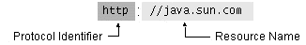

The protocol identifier indicates the name of the protocol to be used to fetch the resource. The example uses the Hypertext Transfer Protocol (HTTP), which is typically used to serve up hypertext documents. HTTP is just one of many different protocols used to access different types of resources on the net. Other protocols include File Transfer Protocol (FTP), Gopher, File, and News.

The resource name is the complete address to the resource. The format of the resource name depends entirely on the protocol used, but for many protocols, including HTTP, the resource name contains one or more of the components listed in the following table:
Host Name | The name of the machine on which the resource lives.
Filename | The pathname to the file on the machine.
Port Number | The port number to which to connect (typically optional).
Reference | A reference to a named anchor within a resource that usually identifies a specific location within a file (typically optional).

Creating URL:
URL dhanush = new URL("http://www.dhanush.in/");

For a Java program to interact with a server-side process it simply must be able to write to a URL, thus providing data to the server. It can do this by following these steps:
- Create a URL.
- Retrieve the URLConnection object.
- Set output capability on the URLConnection.
- Open a connection to the resource.
- Get an output stream from the connection.
- Write to the output stream.
- Close the output stream.

Socket:
A socket is one end-point of a two-way communication link between two programs running on the network. Socket classes are used to represent the connection between a client program and a server program. The java.net package provides two classes--Socket and ServerSocket--that implement the client side of the connection and the server side of the connection, respectively.

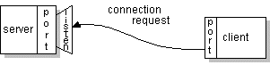

Reading from and Writing to a Socket

Writing a Client/Server Pair:
The previous page showed an example of how to write a client program that interacts with an existing server via a Socket object. This page shows you how to write a program that implements the other side of the connection--a server program.

The UDP protocol provides a mode of network communication whereby applications send packets of data, called datagrams, to one another. A datagram is an independent, self-contained message sent over the network whose arrival, arrival time, and content are not guaranteed. The DatagramPacket and DatagramSocket classes in the java.net package implement system-independent datagram communication using UDP.

This client program is straightforward and simple because the Echo server implements a simple protocol. The client sends text to the server, and the server echoes it back. When your client programs are talking to a more complicated server such as an HTTP server, your client program will also be more complicated. However, the basics are much the same as they are in this program:
- Open a socket.
- Open an input stream and output stream to the socket.
- Read from and write to the stream according to the server's protocol.
- Close the streams.
- Close the socket.

Datagram:
A datagram is an independent, self-contained message sent over the network whose arrival, arrival time, and content are not guaranteed.
Writing a Datagram Client and Server

An example that contains two Java programs that use datagrams to communicate. The server side is a quote server that listens to its DatagramSocket and sends a quotation to a client whenever the client requests it. The client side is a simple program that simply makes a request of the server.

A network interface is the point of interconnection between a computer and a private or public network. A network interface is generally a network interface card (NIC), but does not have to have a physical form. Instead, the network interface can be implemented in software. For example, the loopback interface (127.0.0.1 for IPv4 and ::1 for IPv6) is not a physical device but a piece of software simulating a network interface. The loopback interface is commonly used in test environments.
The java.net.NetworkInterface class represents both types of interfaces.
NetworkInterface is useful for a multihomed system, which is a system with multiple NICs. Using NetworkInterface, you can specify which NIC to use for a particular network activity.

For example, assume you have a machine with two configured NICs, and you want to send data to a server. You create a socket like this:
Socket soc = new java.net.Socket();
soc.connect(new InetSocketAddress(address, port));

To send the data, the system determines which interface will be used. However, if you have a preference or otherwise need to specify which NIC to use, you can query the system for the appropriate interfaces and find an address on the interface you want to use. When you create the socket and bind it to that address, the system will use the associated interface. For example:
NetworkInterface nif = NetworkInterface.getByName("bge0");
Enumeration nifAddresses = nif.getInetAddresses();

Socket soc = new java.net.Socket();
soc.bind(nifAddresses.nextElement());
soc.connect(new InetSocketAddress(address, port));

You can also use NetworkInterface to identify the local interface on which a multicast group is to be joined. For example:
NetworkInterface nif = NetworkInterface.getByName("bge0");
MulticastSocket() ms = new MulticastSocket();
ms.joinGroup(new InetSocketAddress(hostname, port) , nif);

The following methods indicate the network interface type:
isLoopback() indicates if the network interface is a loopback interface.
isPointToPoint() indicates if the interface is a point-to-point interface.
isVirtual() indicates if the interface is a virtual interface.
HTTP State Management with Cookies:
The HTTP state management mechanism specifies a way to create a stateful session with HTTP requests and responses.

Generally, HTTP request/response pairs are independent of each other. However, the state management mechanism enables clients and servers that can exchange state information to put these pairs in a larger context, which is called a session. The state information used to create and maintain the session is called a cookie.

A cookie is a piece of data that can be stored in a browser's cache. If you visit a web site and then revisit it, the cookie data can be used to identify you as a return visitor. Cookies enable state information, such as an online shopping cart, to be remembered. A cookie can be short term, holding data for a single web session, which is, until you close the browser, or a cookie can be longer term, holding data for a week or a year.

Eclipse IDE
Eclipse is an open-source software framework written primarily in Java. In its default form it is an Integrated Development Environment (IDE) for Java developers, consisting of the Java Development Tools (JDT) and the Eclipse Compiler for Java (ECJ). Users can extend its capabilities by installing plug-ins written for the Eclipse software framework, such as development toolkits for other programming languages, and can write and contribute their own plug-in
modules. Language packs are available for over a dozen languages.

Architecture
The basis for Eclipse is the Rich Client Platform (RCP). The following components constitute the rich client platform:
- OSGi - a standard bundling framework
- Core platform - boot Eclipse, run plug-ins
- the Standard Widget Toolkit (SWT) - a portable widget toolkit
- JFace - viewer classes to bring model view controller programming to SWT, file buffers, text handling, text editors
- the Eclipse Workbench - views, editors, perspectives, wizards

Eclipse's widgets are implemented by a widget toolkit for Java called SWT, unlike most Java applications, which use the Java standard Abstract Window Toolkit (AWT) or Swing. Eclipse's user interface also leverages an intermediate GUI layer called JFace, which simplifies the construction of applications based on SWT.
Eclipse employs plug-ins in order to provide all of its functionality on top of (and including) the rich client platform, in contrast to some other applications where functionality is typically hard coded. This plug-in mechanism is a lightweight software componentry framework. In addition to allowing Eclipse to be extended using other programming languages such as C and Python, the plug-in framework allows Eclipse to work with typesetting languages like LaTeX, networking applications such as telnet, and database management systems. The plug-in architecture supports writing any desired extension to the environment, such as for configuration management. Java and CVS support is provided in the Eclipse SDK.
The key to the seamless integration of tools with Eclipse is the plug-in. With the exception of a small run-time kernel, everything in Eclipse is a plug-in. This means that a plug-in you develop integrates with Eclipse in exactly the same way as other plug-ins; in this respect, all features are created equal.
The Eclipse SDK includes the Eclipse Java Development Tools, offering an IDE with a built-in incremental Java compiler and a full model of the Java source files. This allows for advanced refactoring techniques and code analysis. The IDE also makes use of a workspace, in this case a set of metadata over a flat file space allowing external file modifications as long as the corresponding workspace "resource" is refreshed afterwards. The Visual Editor project allows interfaces to be created interactively, hence allowing Eclipse to be used as a RAD tool.

The following is a list of notable projects and plugins for the Eclipse IDE.
These projects are maintained by the Eclipse community and hosted by the Eclipse Foundation.
Core projects
Rich Client Platform (Platform) is the core framework that all other Eclipse projects are built on.
Java Development Tools (JDT) provides support for core Java SE. This includes a standalone fast incremental compiler.
Tools projects
C/C++ Development Tools (CDT) adds support for C/C++ syntax highlighting, code formatting, debugger integration and project structures. Unlike the JDT project, the CDT project does not add a compiler and relies on an external tool chain.
Graphical Editing Framework (GEF) allows developers to build standalone graphical tools. Example use include circuit diagram design tools, activity diagram editors and WYSIWYG document editors.
Web projects
J2EE Standard Tools (JST) extends the core JDT to include support for Java EE projects. This includes EJBs, JSPs and Servlets.
PHP Development Tools (PDT)
Web Standard Tools (WST) adds standards compliant web development tools. These tools include editors for XML, HTML and CSS.
Modeling projects
Eclipse Modeling Framework (EMF) a modeling framework and code generation facility for building tools and other applications based on a structured data model, from a model specification described in XMI.
Graphical Modeling Framework (GMF) is a generative component and runtime infrastructure for developing graphical editors based on EMF and GEF.
Other projects
Test and Performance Tools Platform (TPTP) which provides a platform that allows software developers to build test and performance tools, such as debuggers, profilers and benchmarking applications.
Business Intelligence and Reporting Tools Project (BIRT), an Eclipse-based open source reporting system for web applications, especially those based on Java EE.
Code Snippets

Snapshots

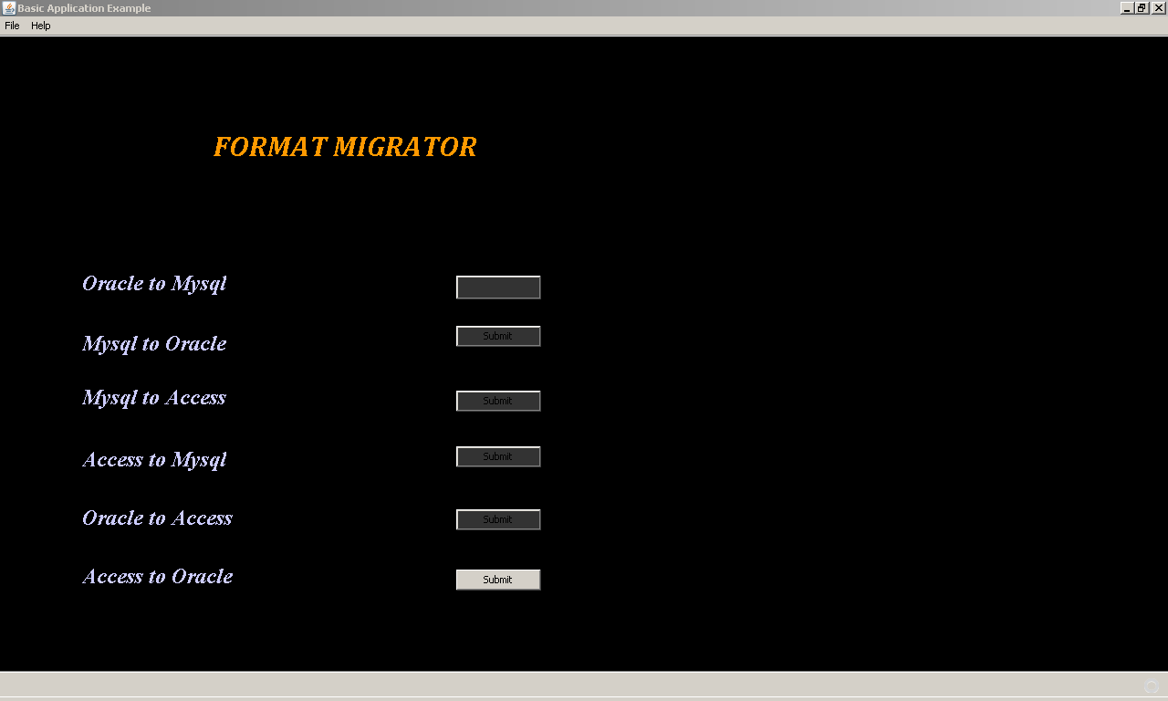

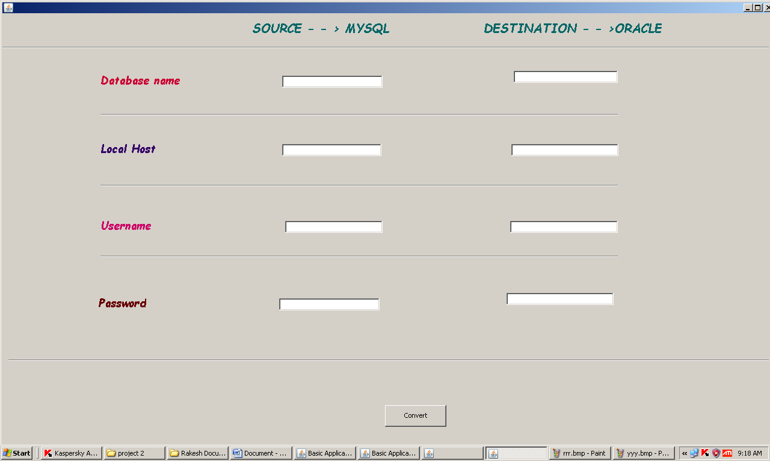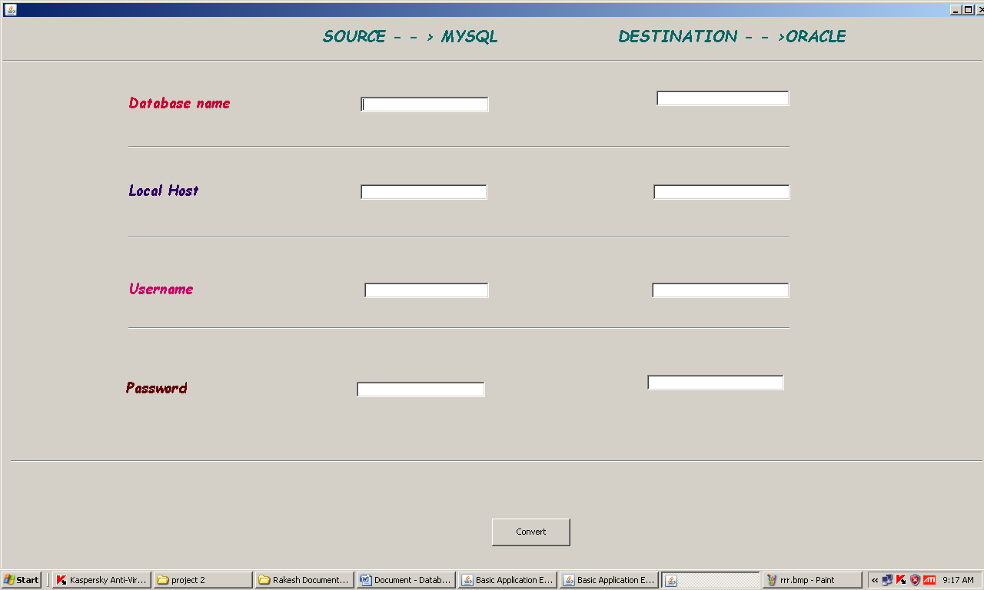

Testing

Software Testing is the process used to help identify the correctness, completeness, security, and quality of developed computer software. Testing is a process of technical investigation, performed on behalf of stakeholders, that is intended to reveal quality-related information about the product with respect to the context in which it is intended to operate. This includes, but is not limited to, the process of executing a program or application with the intent of finding errors. Quality is not an absolute; it is value to some person. With that in mind, testing can never completely establish the correctness of arbitrary computer software; testing furnishes a criticism or comparison that compares the state and behavior of the product against a specification. An important point is that software testing should be distinguished from the separate discipline of Software Quality Assurance (SQA), which encompasses all business process areas, not just testing.

There are many approaches to software testing, but effective testing of complex products is essentially a process of investigation, not merely a matter of creating and following routine procedure. One definition of testing is "the process of questioning a product in order to evaluate it", where the "questions" are operations the tester attempts to execute with the product, and the product answers with its behavior in reaction to the probing of the tester[citation needed]. Although most of the intellectual processes of testing are nearly identical to that of review or inspection, the word testing is connoted to mean the dynamic analysis of the product—putting the product through its paces. Some of the common quality attributes include capability, reliability, efficiency, portability, maintainability, compatibility and usability. A good test is sometimes described as one which reveals an error; however, more recent thinking suggests that a good test is one which reveals information of interest to someone who matters within the project community.

Introduction
In general, software engineers distinguish software faults from software failures. In case of a failure, the software does not do what the user expects. A fault is a programming error that may or may not actually manifest as a failure. A fault can also be described as an error in the correctness of the semantic of a computer program. A fault will become a failure if the exact computation conditions are met, one of them being that the faulty portion of computer software executes on the CPU. A fault can also turn into a failure when the software is ported to a different hardware platform or a different compiler, or when the software gets extended. Software testing is the technical investigation of the product under test to provide stakeholders with quality related information.

Software testing may be viewed as a sub-field of Software Quality Assurance but typically exists independently (and there may be no SQA areas in some companies). In SQA, software process specialists and auditors take a broader view on software and its development. They examine and change the software engineering process itself to reduce the amount of faults that end up in the code or deliver faster.

Regardless of the methods used or level of formality involved the desired result of testing is a level of confidence in the software so that the organization is confident that the software has an acceptable defect rate. What constitutes an acceptable defect rate depends on the nature of the software. An arcade video game designed to simulate flying an airplane would presumably have a much higher tolerance for defects than software used to control an actual airliner.

A problem with software testing is that the number of defects in a software product can be very large, and the number of configurations of the product larger still. Bugs that occur infrequently are difficult to find in testing. A rule of thumb is that a system that is expected to function without faults for a certain length of time must have already been tested for at least that length of time. This has severe consequences for projects to write long-lived reliable software.

A common practice of software testing is that it is performed by an independent group of testers after the functionality is developed but before it is shipped to the customer. This practice often results in the testing phase being used as project buffer to compensate for project delays. Another practice is to start software testing at the same moment the project starts and it is a continuous process until the project finishes.

Another common practice is for test suites to be developed during technical support escalation procedures. Such tests are then maintained in regression testing suites to ensure that future updates to the software don't repeat any of the known mistakes.

It is commonly believed that the earlier a defect is found the cheaper it is to fix it.

 | Time Detected
Time Introduced | Requirements | Architecture | Construction | System Test | Post-Release
Requirements | 1 | 3 | 5-10 | 10 | 10-100
Architecture | - | 1 | 10 | 15 | 25-100
Construction | - | - | 1 | 10 | 10-25
In counterpoint, some emerging software disciplines such as extreme programming and the agile software development movement, adhere to a "test-driven software development" model. In this process unit tests are written first, by the programmers (often with pair programming in the extreme programming methodology). Of course these tests fail initially; as they are expected to. Then as code is written it passes incrementally larger portions of the test suites. The test suites are continuously updated as new failure conditions and corner cases are discovered, and they are integrated with any regression tests that are developed.
Unit tests are maintained along with the rest of the software source code and generally integrated into the build process (with inherently interactive tests being relegated to a partially manual build acceptance process).
The software, tools, samples of data input and output, and configurations are all referred to collectively as a test harness.

History
The separation of debugging from testing was initially introduced by Glenford J. Myers in his 1978 book the "Art of Software Testing". Although his attention was on breakage testing it illustrated the desire of the software engineering community to separate fundamental development activities, such as debugging, from that of verification. Drs. Dave Gelperin and William C. Hetzel classified in 1988 the phases and goals in software testing as follows: until 1956 it was the debugging oriented period, where testing was often associated to debugging: there was no clear difference between testing and debugging. From 1957-1978 there was the demonstration oriented period where debugging and testing was distinguished now - in this period it was shown, that software satisfies the requirements. The time between 1979-1982 is announced as the destruction oriented period, where the goal was to find errors. 1983-1987 is classified as the evaluation oriented period: intention here is that during the software lifecycle a product evaluation is provided and measuring quality. From 1988 on it was seen as prevention oriented period where tests were to demonstrate that software satisfies its specification, to detect faults and to prevent faults. Dr. Gelperin chaired the IEEE 829-1988 (Test Documentation Standard) with Dr. Hetzel writing the book "The Complete Guide of Software Testing". Both works were pivotal in to today's testing culture and remain a consistent source of reference. Dr. Gelperin and Jerry E. Durant also went on to develop High Impact Inspection Technology that builds upon traditional Inspections but utilizes a test driven additive.

White-box and black-box testing
To meet Wikipedia's quality standards, this section may require cleanup.
Please discuss this issue on the talk page, and/or replace this tag with a more specific message.

White box and black box testing are terms used to describe the point of view a test engineer takes when designing test cases. Black box being an external view of the test object and white box being an internal view. Software testing is partly intuitive, but largely systematic. Good testing involves much more than just running the program a few times to see whether it works. Thorough analysis of the program under test, backed by a broad knowledge of testing techniques and tools are prerequisites to systematic testing. Software Testing is the process of executing software in a controlled manner; in order to answer the question “Does this software behave as specified?” Software testing is used in association with Verification and Validation. Verification is the checking of or testing of items, including software, for conformance and consistency with an associated specification. Software testing is just one kind of verification, which also uses techniques as reviews, inspections, walk-through. Validation is the process of checking what has been specified is what the user actually wanted.
- Validation: Are we doing the right job?
- Verification: Are we doing the job right?
In order to achieve consistency in the Testing style, it is imperative to have and follow a set of testing principles. This enhances the efficiency of testing within SQA team members and thus contributes to increased productivity. The purpose of this document is to provide overview of the testing, plus the techniques.
At SDEI, 3 levels of software testing is done at various SDLC phases
- Unit Testing: in which each unit (basic component) of the software is tested to verify that the detailed design for the unit has been correctly implemented
- Integration testing: in which progressively larger groups of tested software components corresponding to elements of the architectural design are integrated and tested until the software works as a whole.
- System testing: in which the software is integrated to the overall product and tested to show that all requirements are met
A further level of testing is also done, in accordance with requirements:
- Acceptance testing: upon which the acceptance of the complete software is based. The clients often do this.
- Regression testing: is used to refer the repetition of the earlier successful tests to ensure that changes made in the software have not introduced new bugs/side effects.
In recent years the term grey box testing has come into common usage. The typical grey box tester is permitted to set up or manipulate the testing environment, like seeding a database, and can view the state of the product after his actions, like performing a SQL query on the database to be certain of the values of columns. It is used almost exclusively of client-server testers or others who use a database as a repository of information, but can also apply to a tester who has to manipulate XML files (DTD or an actual XML file) or configuration files directly. It can also be used of testers who know the internal workings or algorithm of the software under test and can write tests specifically for the anticipated results. For example, testing a data warehouse implementation involves loading the target database with information, and verifying the correctness of data population and loading of data into the correct tables.

Test levels
- Unit testing tests the minimal software component and sub-component or modules by the programmers.
- Integration testing exposes defects in the interfaces and interaction between integrated components (modules).
- Functional testing tests the product according to programmable work.
- System testing tests an integrated system to verify/validate that it meets its requirements.
- Acceptance testing testing can be conducted by the client. It allows the end-user or customer or client to decide whether or not to accept the product. Acceptance testing may be performed after the testing and before the implementation phase. See also Development stage
  - Alpha testing is simulated or actual operational testing by potential users/customers or an independent test team at the developers' site. Alpha testing is often employed for off-the-shelf software as a form of internal acceptance testing, before the software goes to beta testing.
  - Beta testing comes after alpha testing. Versions of the software, known as beta versions, are released to a limited audience outside of the company. The software is released to groups of people so that further testing can ensure the product has few faults or bugs. Sometimes, beta versions are made available to the open public to increase the feedback field to a maximal number of future users.
It should be noted that although both Alpha and Beta are referred to as testing it is in fact use emersion. The rigors that are applied are often unsystematic and many of the basic tenets of testing process are not used. The Alpha and Beta period provides insight into environmental and utilization conditions that can impact the software.
After modifying software, either for a change in functionality or to fix defects, a regression test re-runs previously passing tests on the modified software to ensure that the modifications haven't unintentionally caused a regression of previous functionality. Regression testing can be performed at any or all of the above test levels. These regression tests are often automated.

Test cases, suites, scripts and scenarios
A test case is a software testing document, which consists of event, action, input, output, expected result and actual result. Clinically defined (IEEE 829-1998) a test case is an input and an expected result. This can be as pragmatic as 'for condition x your derived result is y', whereas other test cases described in more detail the input scenario and what results might be expected. It can occasionally be a series of steps (but often steps are contained in a separate test procedure that can be exercised against multiple test cases, as a matter of economy) but with one expected result or expected outcome. The optional fields are a test case ID, test step or order of execution number, related requirement(s), depth, test category, author, and check boxes for whether the test is automatable and has been automated. Larger test cases may also contain prerequisite states or steps, and descriptions. A test case should also contain a place for the actual result. These steps can be stored in a word processor document, spreadsheet, database or other common repository. In a database system, you may also be able to see past test results and who generated the results and the system configuration used to generate those results. These past results would usually be stored in a separate table.
The term test script is the combination of a test case, test procedure and test data. Initially the term was derived from the byproduct of work created by automated regression test tools. Today, test scripts can be manual, automated or a combination of both.
The most common term for a collection of test cases is a test suite. The test suite often also contains more detailed instructions or goals for each collection of test cases. It definitely contains a section where the tester identifies the system configuration used during testing. A group of test cases may also contain prerequisite states or steps, and descriptions of the following tests.
Collections of test cases are sometimes incorrectly termed a test plan. They might correctly be called a test specification. If sequence is specified, it can be called a test script, scenario or procedure.

A sample testing cycle
Although testing varies between organizations, there is a cycle to testing:
- Requirements Analysis: Testing should begin in the requirements phase of the software development life cycle.
During the design phase, testers work with developers in determining what aspects of a design are testable and under what parameter those tests work.
- Test Planning: Test Strategy, Test Plan(s), Test Bed creation.
- Test Development: Test Procedures, Test Scenarios, Test Cases, Test Scripts to use in testing software.
- Test Execution: Testers execute the software based on the plans and tests and report any errors found to the development team.
- Test Reporting: Once testing is completed, testers generate metrics and make final reports on their test effort and whether or not the software tested is ready for release.
- Retesting the Defects
Not all errors or defects reported must be fixed by a software development team. Some may be caused by errors in configuring the test software to match the development or production environment. Some defects can be handled by a workaround in the production environment. Others might be deferred to future releases of the software, or the deficiency might be accepted by the business user. There are yet other defects that may be rejected by the development team (of course, with due reason) if they deem it inappropriate to be called a defect.
Test Cases

Scope for Future Enhancements
Project Summary

The databank tag
Type | Java class for source  Java class for target | Requirements
JDBC | com.lakshya.migrations.MigrationJDBC  com.lakshya.migrations.MigrationJDBC | JDBC 2.0
CSV | com.lakshya.migrations.MigrationCSVSource  com.lakshya.migrations.MigrationCSVTarget
DBF | com.lakshya.migrations.MigrationDBFSource  com.lakshya.migrations.MigrationDBFTarget
XML | com.lakshya.migrations.MigrationSaxXMLSource  - | JAXP 1.0
TXT | -  com.lakshya..migrations.MigrationFreemarkerTarget | Freemarker template engine is used for generating textual files

In this tag we are defining types of the source and the target for this migration, giving the URL and driver parameters to be used.
URL and driver parameters are dependent on types of the source and the target.

Databanks
com.lakshya.dmt.MigrationSaxXMLSource and
com.lakshya.dmt.MigrationFreemarkerTarget are not compatible.

This file will be used for all steps
Full file name is url+file. If this parameter is omited then each step will use own file with name equals to step's name

Type | Attribute | Parameter | S | T | Description
JDBC | url | URL | + | + | URL for the connection
JDBC | driver | DRIVER | + | + | Name of the JDBC driver
JDBC | username | DB USERNAME | + | + | Username for the connection
JDBC | password | DB PASSWD | + | + | Password for the connection
JDBC | quoted-names | quoted | + | + | RDBMS requires names with double quotes
CSV | url | URL | + | + | URL for CSV file
CSV | driver | delimeter | + | + | Fields delimeter in CSV file. By default it is comma
CSV | driver | codepage | + | + | Codepage of CSV file. By default it is Java default codepage
CSV | driver | trim | + | - | If true then removes leading and trailing whitespace; do nothing otherwise
DBF | url | URL | + | + | URL for DBF file
DBF | driver | codepage | + | + | Codepage of DBF file. By default it is Java default codepage
XML | url | URL | + | - | URL for XML file. Supports jar protocol (jar:http://example.org/archive.jar!/)
XML | driver | driver | + | - | Path in XML file of rows. By default path is 'select.row'. Minimum number of tags are two.
TXT | url | URL | - | + | URL for TXT file.
TXT | driver | file | - | + | File name where output of Freemarker will be stored.
TXT | driver | codepage | + | + | Codepage of output file. By default it is Freemarker's default codepage
TXT | driver | template_codepage | + | + | Codepage for templates. By default it is Freemarker's default codepage
TXT | driver | append | - | + | If true then file will be appended. Otherwise it will be recreated. This option is valid only if parameter 'file' is specified. 'true' is by default
Pay attention that JDBC and DBF drivers are not included in DBMT's distribution, so you should add them to your classpath. Of course this tag is mandatory.

The log tag
DBMT uses 'com.lakshya.dmt' JDK14 logger to informate about migration process.
Log level | Messages
FINEST | Target's errors
FINE | Number of inserted rows in commit time
INFO | Information about current process, number of total inserted, filtered, skipped by target's error
SEVERE | Fatal error
In each step there is attribute 'log_level'. MigrationTarget can use for logging all insert commands into file. Now only MigrationJDBC uses this attribute.

The steps tag
Steps are the most important part of a migration and in every step it is defined how the fields of a table should be changed to fit in the new schema. You can write so many step tags as tables we want to migrate.
<step name="EXAMPLE_STEP"
skip='false'
source_table="SOURCE_TABLE.csv"
target_table="TARGET_TABLE"
clear_target="false"
where="INTERNAL is null OR INTERNAL=false"
log_level="OFF"
slice_size="1000"
stop_on_error="true">FIELDS</step>

Format | Attribute | Description
ALL | name | Name of the step. Using in logs.
ALL | skip | If false then the step will be skipped  By default it is false
ALL | where | SQLJEP expression. Variables are names of columns in SOURCE_TABLE
ALL | stop_on_error | If false and an exception occurs in MigrationTarget then the exception will be logged and migration process will be continued  By default it is true
JDBC | source_table | * Select statement. For example 'SELECT f1,f2,f3 from SOURCE_TABLE where id>1000'  * Callable statement. For example 'call dbproc(1,2)'  * Table name. For exmaple 'SOURCE_TABLE'. In this case the following statement will be used 'SELECT * from SOURCE_TABLE'
JDBC | target_table | Table name
JDBC | clear_target | * If true then the following statement will performed 'DELETE from TARGET_TABLE'.  * Callable statement. For example 'call my_clear'.  * If false then do nothing.  By default it is false
JDBC | log_level | * 'FINEST' - all SQL insert statements will be stored in the file 'EXAMPLE_STEP.sql' in the current working directory.  * 'FINER' - all SQL execute time errors of insert stamenets will be stored in file 'EXAMPLE_STEP.sql'.  This attribute is valid only if stop_on_error="false".  By default log_level is OFF
JDBC | slice_size | Number inserted rows into target table without commits. 0 means commit after all rows
XML | source_table | MigrationSaxXMLSource can get XML files from JAR archives. In this case this attribute is name of XML file in JAR archive. Otherwise path to XML file is source.url+source_table
XML | target_table | not implemented
XML | log_level | not implemented
XML | slice_size | not implemented
CSV | source_table | CSV source file. Full path to CSV file is source.url+source_table
CSV | target_table | CSV target file. Full path to CSV file is target.url+target_table
CSV | clear_target | If false then CSV file will be appended. By default it is false
CSV | log_level | not used
CSV | slice_size | not used
DBF | source_table | DBF source file. Full path to DBF file is source.url+source_table
DBF | target_table | DBF target file. Full path to DBF file is target.url+target_table
DBF | clear_target | If false then DBF file will be appended. By default it is false
DBF | log_level | not used
DBF | slice_size | not used
TXT | source_table | not used
TXT | target_table | Freemarker's template file. Full path to template file is target_table. URLs are supported. By default Freemarker uses FileTemplateLoader for loading templates. If an URL is specified in 'target_table' attribute then URLTemplateLoader is used. In the template the source table there is as the collection with name 'SOURCE'.
TXT | clear_target | If false then output file will be appended. By default it is false. This attribute is valid only if there is no 'file' parameter in 'driver' attribute of 'target' tag.
TXT | log_level | not used
TXT | slice_size | Number inserted rows into target table without flushes. 0 means flush after all rows

Next we have to write how the fields will be processed.
<field from="ID"/> <field from="NAME" to="OTHER_NAME"/>
<field from="substr(DESC,1,2)||'_suffix'" to="NEW_DESC"/> <field from="true"
to="LOGIC_FIELD"/>
'from' attribute is mandatory. It can contain name of the field in source table or SQLJEP expresson where variables are names of columns in the source table.
If 'to' is absent then it will be get the same as 'from'.
Some MigrationTarget objects may not have information about types of fields.

For example:
MigrationDBFTarget. When MigrationDBFTarget creates new DBF file it doesn't have information about fields types. And some MigrationSource objects can convert types. For example MigrationDBFSource represents dates only as java.util.Date type but it can convert dates to java.sql.Time or java.sql.Timestamp or java.sql.Date.
For this purposes tag 'field' has attribute 'type'.
Mapping 'type' attribute to Java class

'type' field | Java class
string | java.lang.String
short | java.lang.Short
integer | java.lang.Integer
long | java.lang.Long
logical | java.lang.Boolean
fixed(m,n) or bigdecimal | java.math.BigDecimal
time | java.sql.Time
date | java.sql.Date
timestamp | java.sql.Timestamp

Automatic Generation of Migration File
java -cp XXX com.lakshya.dmt.CreateMigration JDBC_DRIVER URL USERNAME PASSWORD
The file created will be: ./output/migration.xml

Run the Migration
java -cp XXX com.lakshya.dmt.Migration migration1.xml migration2.xml …
Bibliography
Core Java™ 2 Volume I – Fundamentals 7th Edition | - Cay S. Hortsman
Pearson Education – Sun Microsystems | Gary Cornell
Core Java™ 2 Volume II – Advanced | - Cay S. Hortsman
Pearson Education – Sun Microsystems | Gary Cornell
Effective Java – Programming Language Guide | - Joshua Bloch
Pearson Education – Sun Microsystems
Java Swing – Covers Java2 SDK 1.4 2nd Edition  O’Reilly – SPD | - Robert Eckstein, Marc Loy, and Dave Wood
Java Network Programming – First Edition  O’Reilly - SPD | - Elliotte Rusty Harold

